TUGAS PRAKTIKUM 4 PEMROGRAMAN 1



**NAMA: MUHAMAD ARY UTOMO.P**

**NPM : 4513210026**

**TEKNIK INFORMATIKA 2013**

**FAKULTAS TEKNIK**

**UNIVERSITAS PANCASILA**

**PROGRAM 401 :**

**SOURCECODE**

|  |
| --- |
| import java.util.Scanner;  public class program401{  public static void main (String[]args){  int i;  for(i=0; i<10; i++)  {  System.out.println("Belajar java "+i);  }  }  } |

**PRINTSCREEN**

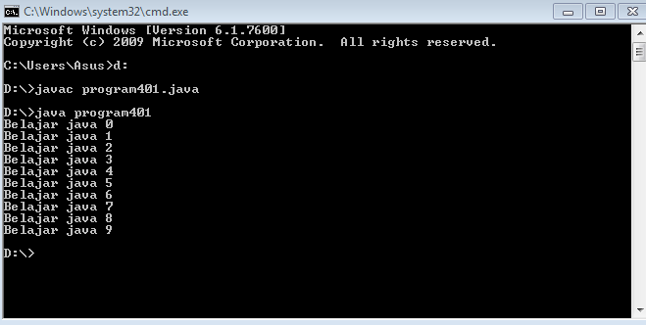

**PROGRAM 402 :**

**SOURCECODE**

|  |
| --- |
| import java.util.Scanner;  public class program402{  public static void main (String[]args){  int i;  for(i=0; i<20; i+=2){  System.out.println("i= "+i);  }  }  } |

**PRINTSCREEN**

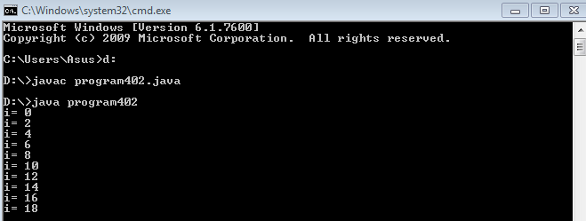

**PROGRAM 403 :**

**SOURCECODE**

|  |
| --- |
| import java.util.Scanner;  public class program403{  public static void main (String[]args){  int i;  for(i=13; i<=100; i++)  {  if (i % 2 ==0)  {  System.out.println(i);  }  }  }  } |

**PRINTSCREEN**

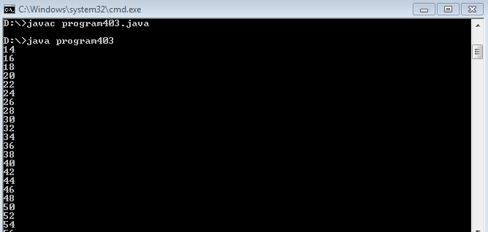

**PROGRAM 404 :**

**SOURCECODE**

|  |
| --- |
| import java.util.Scanner;  public class program404{  public static void main (String[]args){  int i,jumlah;  jumlah=0;  for (i=0; i<=10; i++){  jumlah=jumlah + i;  System.out.println (jumlah);  }  }  } |

**PRINTSCREEN**

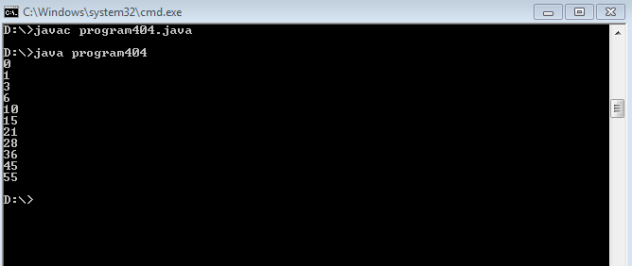

**PROGRAM 405 :**

**SOURCECODE**

|  |
| --- |
| import java.util.Scanner;  public class program405{  public static void main (String[]args){  int i,jumlah;  jumlah=0;  for (i=0; i<=10; i++)  {jumlah=jumlah + i;  if(jumlah % 2 ==1){  System.out.println (jumlah);  }  }  }  } |

